**The Picasso face**

This project has been conceived taking into consideration the setting of ***Jornada Extendida*** in the province of Córdoba. The projects aims at easing students´ learning of the language by establishing connections between subjects, in this case, English and Art. We have use unit 3 of our material as starting point for the project. Students will have already acquired the necessary vocabulary to talk about the face. The use of the artistic expression will give the students the possibility to develop their creativity, self expression and artistic sensitivity (2). When children are involved in art making process the value the creative process, the opportunity to work individually or in groups, and the new ways in which they learn to express themselves. As Vickor Lowenfeld states “La educación artística puede proporcionar la oportunidad para incrementar la capacidad de acción, la experiencia, la redefinición y la estabilidad que son imprescindibles en una sociedad llena de cambios, tensiones e incertidumbres” (3)

1. pag 37 Lowenfeld Viktor,Desarrollo de la capacidad creadora, Editorial Kapeluz Buenos Aires ,1980
2. pag 31, Lowenfeld Viktor, Desarrollo de la capacidad creadora, Editorial Kapeluz Buenos Aires ,1980

**Introduction: Warm up**

T shows three different portraits and asks Ss questions:

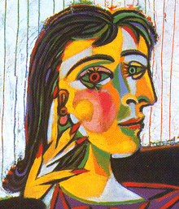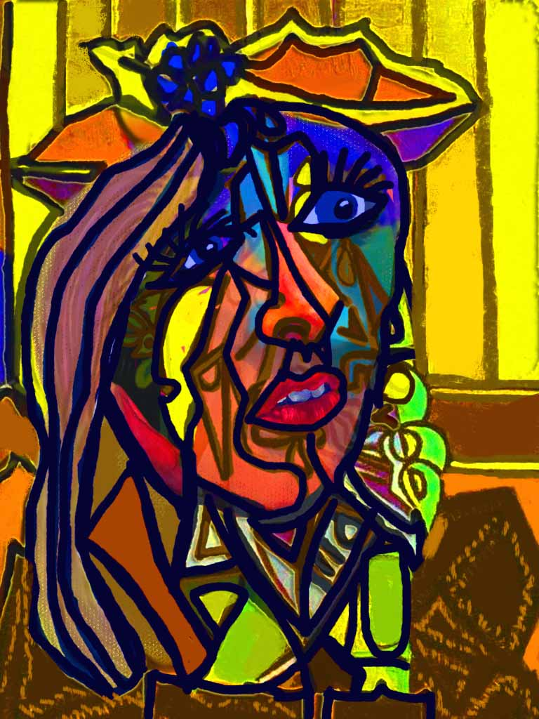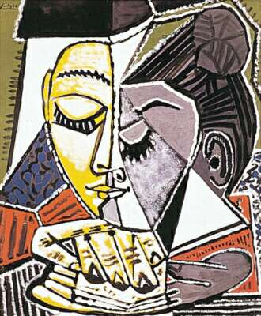

1) What colors can you see?

2) What can you see? (T elicits body parts)

T helps Ss to focus on Picasso's painting technique.

**Presentation**

First, T introduces *Pablo Picasso's biography*. T shows this picture and may also include his self- portraits.

Second, T introduces *Cubism*. She explains it main traits, its innovative technique and the importance of this movement in art.

You can find useful information about Picasso and Cubism in the following links:

http://www.biography.com/people/pablo-picasso-9440021#early-life-and-education&awesm=~oIHW6bZzQLgziR

http://www.picasso.com/productlist.aspx?id=32147

**Introduction of the project:**

T introduces the activity. T sticks the portraits on the blackboard where all Ss can have a look at them. Then T asks Ss to elaborate their own self portrait using different materials. Possible materials:

First option

Water colors, tempera paint, brush and paper.

Second option

You can ask Ss to bring different pictures of faces from magazines and ask them to cut and paste on a paper different body parts from the different pictures they have brought.

Third option

If you have Internet access or access to a computer lab, there is a tool on the Internet that will allow you to create your own Picasso face. Visit the page: picassohead.com

**While on task activity.**

T walks around the classroom and asks questions about Picasso's life or/also about the students' work. T may elicit the name of different body parts as well as colors.

Sites consulted

http://makingartfun.com/htm/f-maf-art-library/picasso-cookie.htm

http://m.voices.yahoo.com/picasso-kids-lesson-plans-printables-5732496.html

http://m.voices.yahoo.com/pablo-picasso-free-art-lesson-plans-resources-5263159.html?cat=9

Bibliography

Acerete,Dora M.,Guia para el maestro de grado, Editorial Kapeluz,Buenos Aires ,1980

Read,Herbert,Educaciónpor el Arte, Editorial Paidos,1995,Barcelona España

Lowenfeld Viktor,Desarrollo de la capacidad creadora, Editorial Kapeluz Buenos Aires ,1980

Propuesta para ayudar a mirar. Guías para alumnos, docente y público en general. Sala de Exposiciones Ernesto Farina, Ciudad de las Artes.Cordoba, 2008.